Water Emergency: Nano to the Rescue!
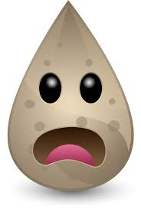
Imagine that you’re lost in the forest and ran out of clean water.
All you can find is dirty river water! What would you do?
Objective: Purify the contaminated water!
Materials:
- Petri dishes
- Dropper bottles
- Dirty water (blue dye)
- Titanium dioxide nanoparticles
- Ultraviolet light (nail salon lamp – or the SUN works too!)
Procedure:
- Prepare three petri dishes:
  - 5 full droppers of water + 2 drops of dye Place under the light
  - 5 full droppers of nanoparticles + 2 drops of dye Place under the light
  - 5 full droppers of nanoparticles + 2 drops of dye Keep out of light
What color is each sample?
- Turn on the UV lamp. Wait 2 minutes. Compare the three dishes.
What color is each sample now? Which one is clean (not blue)?
What happened?
Have you heard of “nano” before? “Nano” means very small. “Nanoparticles” are bigger than atoms but smaller than a cell – so small you can’t even see them! Even though nanoparticles are tiny, they can do amazing things!
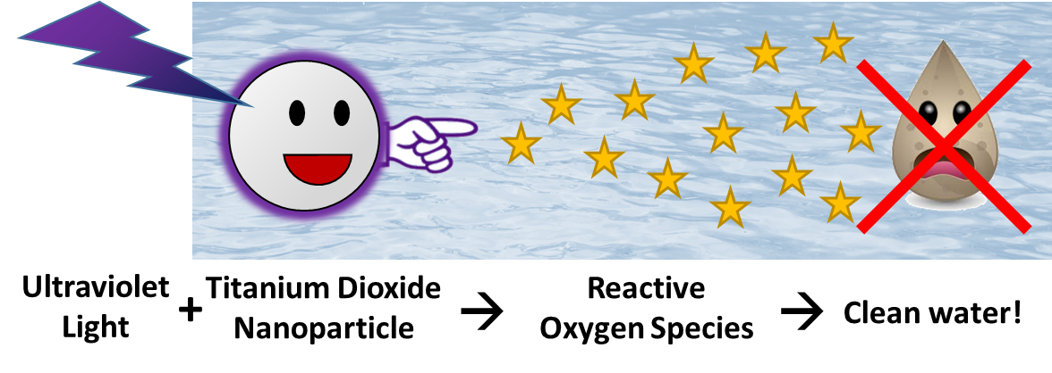
The titanium dioxide nanoparticles in this experiment are activated by ultraviolet light and even sunlight. When the light hits the nanoparticle, it starts a chain reaction: an electron from the nanoparticle reacts with oxygen or water to form reactive oxygen species. The reactive oxygen species can destroy contaminants like the blue dye or germs in the water that could make you sick. This technology can be used to clean water and make it safe to drink!

