Glassware Cleaning Tips – Louie Group (email corrections to slouie@uh.edu)
- Avoid letting sample or soap solution dry in the glassware. Once contaminants dry on the glassware, they become much more difficult and sometimes impossible to remove. Immediately rinse and move to a cleaning bath.
- When placing containers in a cleaning bath, avoid “floaters.” Make sure the container is fully submerged under the liquid surface without air bubbles: manually push the container under the water and turn the open side up to allow air bubbles to escape. Any surface that is not in contact with the cleaning solution is not being cleaned:
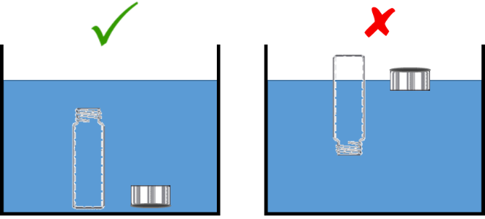

- Cover the cleaning bath if soaking for long time periods, to minimize evaporation and drying.
- To check cleanliness: Fill the container with water and pour out the water. The water should “sheet” down the sides of the glassware. If droplets of water are observed clinging to the glassware, there is some residue remaining that should be cleaned further if rigorously clean glassware is needed.
Cleaning Procedure for Aqueous Samples:
First, read the general guidelines from Sigma Aldrich and AceGlass.
Step-by-step instructions are listed here for ease of following in lab.
Option A. Soap bath (typical procedure for our lab, for mild or moderate cleaning)
Some information that may help choose between the different types of soap: TedPella / Alconox
1) Wear the appropriate PPE (gloves, safety glasses, lab coat).
2) Rinse the dirty container with water first. If residue is observed on the surface, scrub with a brush if scratching is not critical (Do not scrub optical glass or quartz! If absolutely necessary, use a foam- or cotton-tipped swab).
3) Soak the glassware overnight in a soap bath (e.g., Liquinox, Alconox, or Contrad 70 solution).
Follow the manufacturer’s directions to dilute the soap and check for any specific cleaning protocol.
4) Another brush scrubbing may be performed after soaking.
5) Rinse with water until no more soap suds are visible, then rinse at least 6 more times with DI water.
6) An ethanol rinse may optionally be added, followed by an additional 6 DI water rinses.
7) Dry by air-drying or in a drying oven.
Option B. Acid cleaning (for thorough cleaning, e.g. heavy organic or inorganic residues)
1) Wear the appropriate PPE (rubber gloves, safety glasses, lab coat).
2) Rinse the dirty container with water first. If residue is observed on the surface, scrub with a brush if scratching is not critical (Do not scrub optical glass or quartz! If absolutely necessary, use a foam- or cotton-tipped swab).
3) Prepare up to 10% HCl or up to 10% HNO₃ for the acid bath. Concentrated acid baths must be prepared and located in a chemical fume hood and labeled. Soak the glassware overnight in the bath. Optionally, the container to be cleaned may be filled with the acid solution, covered, and left in secondary containment (labeled) in a hood.
4) Rinse at least 6 times with DI water. Dry by air-drying or in a drying oven.
Option C. Ultrasonic cleaning – NOT for optical glassware (e.g. cuvettes, photoreactor vials)
1) Wear the appropriate PPE (gloves, safety glasses, lab coat).
2) Rinse the dirty glassware with water first. Then place in a beaker of clean DI water or mild soap solution and bath sonicate. Follow safety instructions for the sonicator (e.g. use a basket instead of placing containers on the bottom of the sonicator). Do not use for optical glassware to avoid etching.
3) Rinse at least 6 times with DI water. Dry by air-drying or in a drying oven.
Cuvette Cleaning:
Cleaning solutions for quartz cuvettes (e.g. for UV-vis or fluorescence spectrometers) can be purchased.
A detailed list of options is also available from FireflySci.
Cleaning Procedure for Organic Samples:
As our lab does not typically work with organic solutions, you are advised to look up cleaning procedures elsewhere. An organic solvent will be needed, such as acetone. A miscibility table will be helpful.
Special notes for nanoparticle contamination:
If inorganic nanoparticles are observed stuck to glassware after the above cleaning procedures, it is advisable to discard the glassware instead of attempting further cleaning. Especially problematic nanoparticles include the following:
Titanium dioxide (TiO₂) nanoparticles: TiO₂ does not dissolve in typical cleaning solutions. A TiO₂ dissolution procedure is available from DuPont but requires the use of heated H₂SO₄, which is too hazardous to be worthwhile for regular glassware cleaning.
Gold (Au) nanoparticles: Au can be dissolved using aqua regia, but this is too hazardous to be worthwhile for regular glassware cleaning. Dilute aqua regia, e.g. 1.0 % v/v, 3 parts HCl/1 part HNO₃, may work and could be acceptable, but ask for permission first.

