Recommendations for Good Laboratory Practice

Always work safely: Follow safety protocols and wear all personal protective equipment.
Work Smart! Reliable methods, good lab technique, and thorough planning form the basis of all experiments. Planning ahead and verifying the validity of your analytical (measurement) protocols and experimental method before getting too far into your project will ultimately save time and resources. If experiments are rushed through with faulty sample preparation or flawed measurements, the results need to be discarded and experiment will need to be redone.
One-time preparation, before using a new analytical instrument or experimental protocol:
  - Pre-lab assignment: Study the instrument manuals or watch online training videos to learn the function and proper use of each piece of equipment (pipetters, centrifuge, spectrometers, etc.).
  - Study and follow protocols in detail as written. Try to understand the theory or purpose behind each step of the protocol.
    - For published protocols: Print the protocol, highlight, and take notes. Re-write the steps in your own words to ensure you understand the method and aren’t missing steps.
    - For verbal or in-person training: Listen carefully and take thorough notes. Immediately after the training, re-organize and re-write your notes to ensure you understand all steps.
    - Ask the PI, lab manager, or senior grad students if you have questions or need clarification!
  - Practice methods and verify they work correctly using known standards and only a few samples. Make any adjustments needed for your specific samples, e.g. to correct for interferences. Do this before preparing a large set of samples to avoid having to remake and re-measure samples.
For every experiment:
  - Plan the experiment and double-check, before taking any actions in lab:
    - Write out the desired sample preparation (e.g., dilutions) and experiment, and verify that the calculations (e.g. final concentration of samples, buffers, etc.) are correct.
    - Estimate how much time and materials (chemicals, vials, centrifuge tubes, etc.) are needed to complete the entire experiment. Do you have everything you need? Will samples go bad before you can take all the measurements? Split the experiment into a manageable number of samples to avoid having to redo experiments.
    - Verify that all instruments and materials are clean, working correctly, available in the quantities needed, and available at the time needed (e.g. when the sample is collected).
  - Finally… you can go to lab! Be sure to take thorough records in your lab notebook.
    - Set up your lab notebook page: Record the date, the purpose of your experiment, supplier and lot number for materials used, and tables of the sample preparation (e.g., dilutions). Bring your printed or written protocol to follow closely in lab during your experiment or measurement. Digital copies are more difficult to follow and are not advisable.
    - Prepare the samples, run the experiment, and collect samples. Record in your lab notebook.
3. Time to take measurements! Critically evaluate the quality of the data during data collection.
    - Check the instrument performance to verify it is clean and working correctly.
    - Collect the calibration curve before every set of samples if applicable, plot it, and verify that the calibration is linear (both visually and by checking for R² > 0.99). For instruments that should produce reproducible measurements (e.g., UV-vis spectrometer), verify that the measurements for your calibration standards, as well as the slope and intercept of the calibration curve, are similar to previous calibrations. If not, stop and correct the problem before moving on.
    - Measure each sample. While working, think critically about whether the data are of good quality and make physical sense (e.g., verify that you didn’t measure any negative concentrations, that your sample eluted out of the chromatographic column, that the flow cell/crystal/cuvette is clean, etc.). If not, stop and consider what might have gone wrong. Retake the measurements if it’s possible to make a quick correction.
    - Analyze the data and check if any other corrections are needed before starting the next experiment.
Data Files:
Get into the habit of structuring your folder and file names for easy access and recollection in the future. A suggested file organization is shown in Figure 1 below. Note the use of YYYY.MM.DD format in the folder names to preserve chronological organization, providing a descriptive name for folders and files, and numbering the file names in the order collected (more important for multi-step measurements).
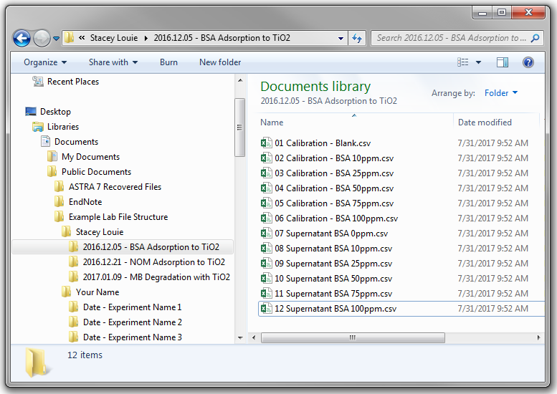
Figure 1. File organization example
Supplies: We have a limited supply budget. Use whatever is needed, but try to minimize the amount and volume of samples and number of disposable items used. Wash and reuse containers if possible. If a supply is running out, notify others in the lab and prepare an order form to replenish the supply.

